Project Planning Phase
Project Planning Template (Product Backlog, Sprint Planning, Stories, Story points)
Date | 01 September 2026
Team ID | Individual Project
Project Name | Software Installation Request Automation in ServiceNow
Maximum Marks | 5 Marks
Product Backlog, Sprint Schedule, and Estimation (4 Marks)
Use the below template to create product backlog and sprint schedule.
Sprint | Functional Requirement (Epic) | User Story Number | User Story / Task | Story Points | Priority | Team Members
Sprint-1 | Service Catalog Setup | USN-1 | As an individual project owner, I can create an Update Set to capture the project configuration changes. | 2 | High | Individual
Sprint-1 |  | USN-2 | As an employee, I can submit a standardized Software Installation Request catalog item. | 3 | High | Individual
Sprint-1 |  | USN-3 | As a requester, I can enter Software Name, Version Required, License Justification, and Urgency. | 5 | High | Individual
Sprint-1 |  | USN-4 | As a requester, I can test the catalog item and verify that the submitted request is created correctly. | 2 | High | Individual
Sprint-1 | Request Tracking | USN-5 | As an administrator, I can verify the request and requested-item records for the submitted catalog request. | 3 | Medium | Individual
Sprint-1 |  | USN-6 | As an administrator, I can configure basic requester notifications for the request lifecycle. | 5 | Medium | Individual
Sprint-2 | Workflow & Fulfillment | USN-7 | As an administrator, I can create an automation flow/workflow for the software installation request. | 5 | High | Individual
Sprint-2 |  | USN-8 | As an approver, I can receive and process the approval for a software installation request. | 3 | High | Individual
Sprint-2 |  | USN-9 | As an IT support member, I can receive an automatically created fulfillment task. | 5 | High | Individual
Sprint-2 |  | USN-10 | As an administrator, I can attach the workflow/flow to the Software Installation Request catalog item. | 2 | High | Individual
Sprint-2 |  | USN-11 | As an IT support member, I can update the task state from Open to Work in Progress to Completed. | 3 | Medium | Individual
Sprint-2 |  | USN-12 | As a requester, I can receive progress notifications during approval and fulfillment. | 2 | Medium | Individual
Sprint-3 | Exception Handling & Business Rules | USN-13 | As an administrator, I can validate sc_request and sc_req_item records after request submission. | 3 | High | Individual
Sprint-3 |  | USN-14 | As an administrator, I can create a Business Rule that detects a software request placed On Hold. | 5 | High | Individual
Sprint-3 |  | USN-15 | As an administrator, I can create an incident automatically when a license shortage prevents fulfillment. | 5 | High | Individual
Sprint-3 |  | USN-16 | As an administrator, I can configure SLA tracking for timely software request fulfillment. | 3 | Medium | Individual
Sprint-3 |  | USN-17 | As an administrator, I can test the license shortage and incident-creation scenario. | 2 | Medium | Individual
Sprint-3 |  | USN-18 | As an administrator, I can review request and fulfillment records for reporting purposes. | 2 | Low | Individual
Sprint-4 | Testing & Deployment | USN-19 | As an administrator, I can execute end-to-end testing of catalog, approval, task, notification, and exception handling. | 5 | High | Individual
Sprint-4 |  | USN-20 | As an administrator, I can complete the project Update Set after configuration is finalized. | 2 | High | Individual
Sprint-4 |  | USN-21 | As an administrator, I can export the completed Update Set as XML. | 2 | High | Individual
Sprint-4 |  | USN-22 | As an administrator, I can retrieve the Update Set in another instance for deployment testing. | 3 | High | Individual
Sprint-4 |  | USN-23 | As an administrator, I can preview and commit the Update Set without missing configuration elements. | 3 | High | Individual
Sprint-4 |  | USN-24 | As an administrator, I can validate that all transferred configurations work correctly after deployment. | 5 | High | Individual
Project Tracker, Velocity & Burndown Chart: (4 Marks)
Sprint | Total Story Points | Duration | Sprint Start Date | Sprint End Date (Planned) | Story Points Completed (as on Planned End Date) | Sprint Release Date (Actual)
Sprint-1 | 20 | 6 Days | 09 Aug2026 | 14 Aug2026 | 20 | 14 Aug 2026
Sprint-2 | 20 | 6 Days | 15 Aug2026 | 20 Aug2026 | 20 | 20 Aug 2026
Sprint-3 | 20 | 6 Days | 21 Aug2026 | 26 Aug2026 | 20 | 26 Aug 2026
Sprint-4 | 20 | 6 Days | 27 Aug2026 | 01 Sep2026 | 20 | 01 Sep 2026

Velocity:
Imagine we have a 6-day sprint duration, and the velocity of the individual project is 20 story points per sprint. Let’s calculate the average velocity (AV) per iteration unit (story points per day).
Total Story Points = 20 + 20 + 20 + 20 = 80
Number of Sprints = 4
Velocity = 80 / 4 = 20 Story Points per Sprint
Average Velocity per Day = 20 / 6 = 3.33 Story Points per Day
Burndown Chart:
A burn down chart is a graphical representation of work left to do versus time. It is often used in agile software development methodologies such as Scrum. However, burn down charts can be applied to any project containing measurable progress over time.
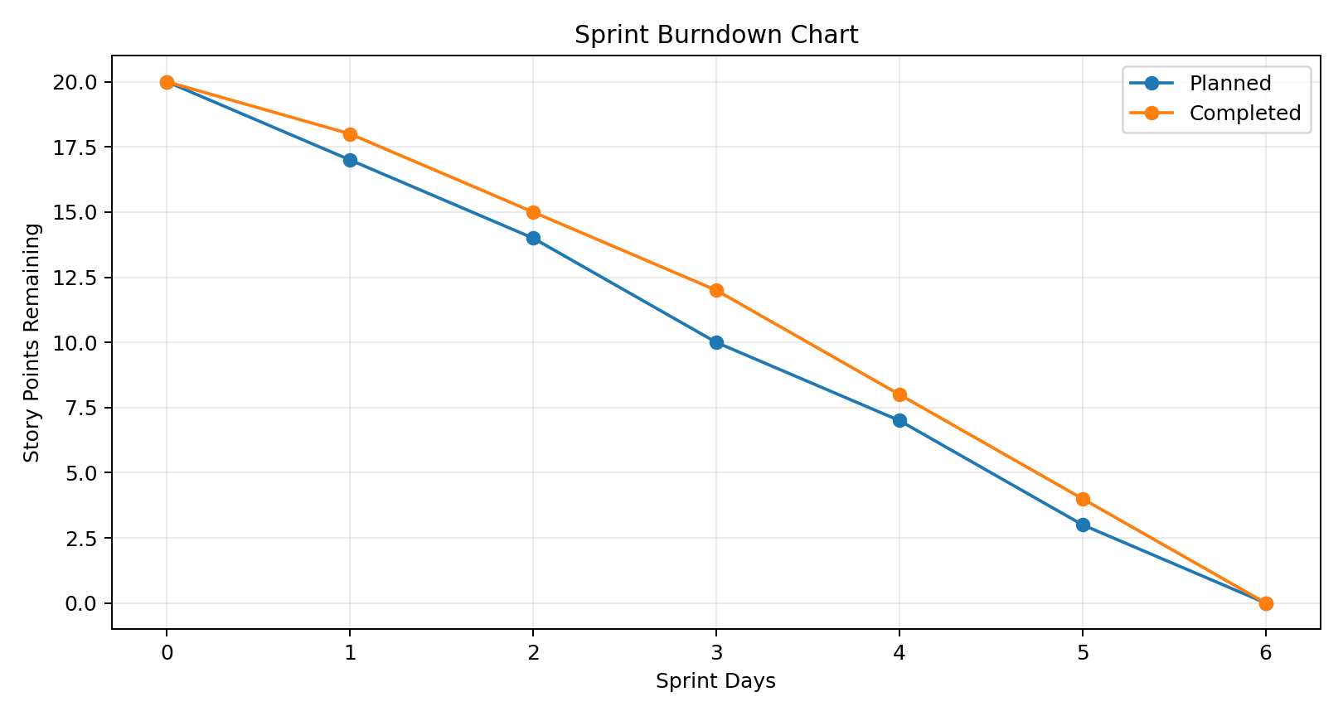

Planning Summary: The backlog is divided into four planned Sprints. Sprint 1 focuses on Service Catalog setup and request tracking; Sprint 2 focuses on workflow and fulfillment; Sprint 3 covers Business Rules, SLA and exception handling; Sprint 4 covers end-to-end testing and Update Set deployment.
Reference: https://www.atlassian.com/agile/project-management

